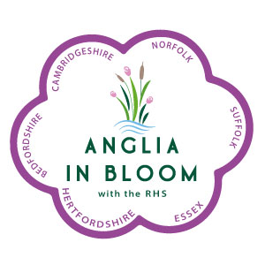
ANGLIA IN BLOOM
MARKING SHEET
Public House, Shop Front, Restaurant, Hotel

These can be any size but must have improved the setting in which they situated. They should be in a public area and not a private garden and be on full public display They must be demonstrate good design, colour combinations, appropriate choice of plants, innovation, quality of plants, cultivation, maintenance and/or special features.

A portfolio is not required for this category

 |  | Max | Awarded
A | Design. Does it sit well in the location? Is there instant impact? | 20
B | Colour combinations | 5
C | Appropriate choice of plants | 5
D | Innovation Is there a stand out feature? A ‘wow’ factor? | 10
E | Quality of plants Good cultivars? No bruising? | 20
F | Cultivation In appropriate containers? In appropriate locations? | 15
G | Maintenance Any dead heads visible? Well watered? | 15
H | Special features Something memorable? | 10
 | Total Points | 100

Please write a short report to be given to entrant at Judges’ Seminar on what was good and what would have increased their score.

