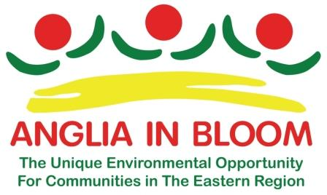 ANGLIA IN BLOOM I.Y.N. ENTRY FORM

Name of It’s Your Neighbourhood Entry:
Location of Neighbourhood Entry:
_______________________________________________________________________________________________
Contact Name (1)
Address:

Landline Number: Mobile No. e-mail address
Contact Name (2)
Address:

Landline Number: Mobile No. e-mail address
Disclaimer: Anglia in Bloom/RHS Britain in Bloom reserve the right to use any photographs/details supplied
by entrants for publicity, editorial and web content.
Anglia in Bloom will be pleased to receive your It’s Your Neighbourhood entry on behalf of RHS Britain in Bloom. Please complete this form, preferably in block capitals or typed (to make it easier to read, and send to:
Anglia in Bloom, Mrs Margaret Spencer, 102 London Road, Rayleigh, Essex, SS6 9JA.
THERE IS NO FEE FOR I.Y.N. ENTRIES
Please ensure your entry arrives before April 1st.

Anglia in Bloom Patrons: Peter Bales Roses ***** Notcutts Garden Centres.
Sponsors: Amberol Ltd.: Barcham Trees: C.G.M. Group: Searles Leisure: Harrowden Turf

