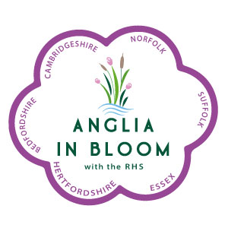
ANGLIA IN BLOOM
MARKING SHEET
Special Feature for King’s Coronation

These can be any size but must have an impact and depict what is being celebrated. Display should be in a public area and not a private garden and be on full public display Display must be demonstrate good design, colour combinations, appropriate choice of plants, innovation, quality of plants, cultivation, maintenance and be appropriate to the occasion. Up to 3 displays can be entered.

A portfolio is not required for this category

 |  | Max | Awarded
A | Design. Does it sit well in the location? Is there instant impact? | 20
B | Colour combinations | 5
C | Appropriate choice of plants | 5
D | Innovation Is it obviously celebrating a Coronation? | 20
E | Quality of plants Good cultivars? No bruising?Does it give ‘wow’ factor | 10
F | Cultivation In appropriate containers? In appropriate locations? | 15
G | Maintenance Any dead heads visible? Well watered? | 15
H | Information Does it give information about the Coronation | 10
 | Total Points | 100

Please write a short report to be given to entrant at Judges’ Seminar on what was good and what would have increased their score.

