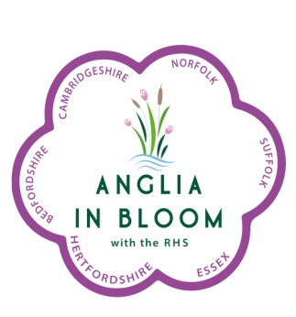 Anglia in Bloom Entry Form

THIS FORM CAN BE USED FOR MAIN AND ADDITIONAL CATEGORIES ENTERED
(Separate form for each entry)

Name of Entry:
Number of Young People's Entries included in MAIN judging tour:  (Max 2, additional 15 min for each young people’s entry to be view.) |  |  |  | Please circle as appropriate  1 2
Category entered: Park/Cemetery/Pub, etc. |  | *Electoral Roll numbers/ Size (as applicable) |  |  | Fee Payable
Contact Name 1
Address
Contact phone Number | Mobile |  | Email
Contact Name 2
Address
Contact phone Number | Mobile |  | Email
Disclaimer – Anglia in Bloom reserve the right to use any photographs supplied by Entrants for
Publicity, editorial and web content

Your entry into Anglia in Bloom is invited. Please complete this form, preferably in block capitals or typed to make it easier to read, and send it with a cheque made payable to Anglia in Bloom to:

Mrs. Margaret Spencer (Treasurer) 102 London Road, Rayleigh, Essex, SS6 9JA

Alternatively Direct Bank payments can be made to: Account – Anglia in Bloom.
Account No.90704385, Sort Code 20-62-53
*PLEASE MAKE SURE THIS INFORMATION IS CORRECT. We will make random checks.

Sponsors Amberol Ltd, Barcham Trees, LK Construction Ltd.

