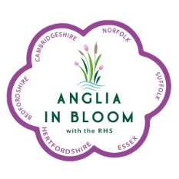

ANGLIA IN BLOOM
It’s Your Neighbourhood Entry Form
Name of It’s Your Neighbourhood Entry:
Location of Neighbourhood Entry:
Contact Name (1):
Address:
Land Line Number: | Mobile Number: | Email address:
Contact Name (2):
Address:
Land Line Number: | Mobile Number | Email address
Disclaimer: Anglia in Bloom/RHS Britain in Bloom reserve the right to use any photographs /details supplied by entrants for publicity, editorial and web content.
Privacy Notice: I am aware that for purposes of Anglia in Bloom and IYN, my data may be shared with the RHS and stored and processed in compliance with the General Data Protection Regulation.
Anglia in Bloom will be pleased to receive your It’s Your Neighbourhood entry on behalf of RHS Britain in Bloom. IYN is free to enter.
Please complete this form, preferably in block capitals or typed (to make it easier to read, and email it to:
Mrs Margaret Spencer (Treasurer),
Email: Margaret-spencer@esec.uk
*Postal address available on request

